**PHARMACY MANAGEMENT SYSTEM**

**1-) What is Dietitian website?**

**dietitian website; It is a website where customers find healthy food and beverage recipes and buy necessary supplements, as well as get support from a dietitian online. It** .

**2-) Aim of Dietitian website**

The main aim of a dietitian website is to provide information and resources to the general public, patients, and clients on healthy eating, nutrition, and lifestyle management. This includes providing information on the services offered by the dietitian, such as consultation, assessment, nutrition education, and therapy. A dietitian website can also serve as a platform for the dietitian to establish a professional online presence and to communicate with their clients and patients.

Additionally, these website can aim to:

Improve patient engagement by providing them with educational materials, interactive tools, and mobile apps for tracking their progress.

Make it easy for potential clients and patients to learn about the dietitian's services and qualifications, and to contact the dietitian to schedule appointments.

Promote the dietitian's practice and expertise by highlighting their experience, qualifications, and publications.

Provide valuable information and resources for the public about nutrition and health, this can serve as a way for the dietitian to establish themselves as a reliable source of information and knowledge.

Encourage patients to follow through with their treatment plans by using it as an additional tool for keeping the patient informed, motivated and engaged.

**3-) Benefits of Dietitian website Management System**

Improved communication and engagement with clients by providing an online platform for scheduling appointments, tracking progress, and access to personalized nutrition plans.

Increased visibility and credibility of your practice through an easy-to-use website that can be accessed by clients, referrals, and other healthcare providers.

Streamlined client management and scheduling through automated appointment reminders, client information tracking and easy access to client's data.

Increased revenue by reaching more clients and providing online consultations and meal plans.

Better record-keeping and reporting capabilities.

Improved client satisfaction through easy access to their health information and personalized plans.

Cost savings through reduced administrative tasks and improved client retention.

Facilitation of compliance with legal and regulatory requirements.

Dietitians can access client's data and history in a timely manner.

Ability to provide online resources such as recipes, articles and educational materials to clients.

## **4-) Entity Relationship Diagram**

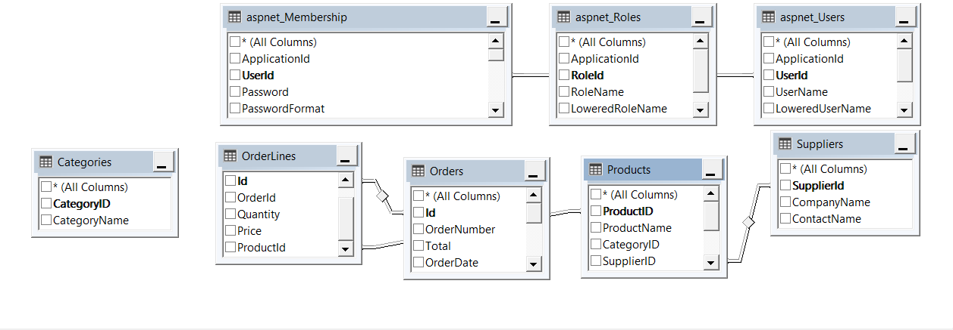

## **5-) Scenarios**

1. **Login in as a User** 
   * 1. User should be saved to system.
     2. Enter Login page.
     3. Then, Enter User information
        1. User Name
        2. Password
     4. Click login button.
     5. Login is confirmed
2. **Register to the System**
   * 1. Enter Register Page.
     2. Add new User information

- UserName

- Email address

- Password

- Confirm password

* + 1. Click Register Button
    2. Register is confirmed

1. **Add To Cart**
   * 1. First, it must be Registered to the system.
     2. Go to the supplement page.
     3. Then, go to the supplement details.
     4. Add to cart.
     5. Add To Cart is completed
2. **Give an Order**
   * 1. First, it must be Registered to the system.
     2. Go to the supplement page.
     3. Then, go to the supplement details.
     4. Add to cart.
     5. Add To Cart is completed.
     6. Then, click complete the shopping button.
     7. fill Order information

- UserName get fill automatically

- Address Description

- Address

- City

- District

- Neighborhood

- Post Code

* + 1. click submit button.
    2. Order completed.

1. **Create product** 
   * 1. First, it must be a admin.
     2. Then, using admin username and password can log in to system
     3. Go to the products page.
     4. Create new Products

- ProductName

- CategoryID

- SupplierID

- UnitPrice

- UnitInStock

- IsHome

- IsApproved

* + 1. Click Create Button
    2. Create product is completed.

1. **Delete Product**
   * 1. First, it must be a admin.
     2. Then, using admin username and password can log in to system
     3. Go to the products page.
     4. Select product..
     5. Delete Product.
     6. Deleting is confirmed
2. **Edit Product**
   * 1. First, it must be a admin.
     2. Then, using admin username and password can log in to system
     3. Go to the products page.
     4. Select product.
     5. Edit which information you want to update

- ProductName

- CategoryID

- SupplierID

- UnitPrice

- UnitInStock

- IsHome

- IsApproved

* + 1. Editing is confirmed

1. **Show Details Product**
   * 1. First, it must be a admin.
     2. Then, using admin username and password can log in to system
     3. Go to the products page.
     4. Select product.
     5. Click Details Button
     6. Show Details is confirmed
2. **Create Categories** 
   * 1. First, it must be a admin.
     2. Then, using admin username and password can log in to system
     3. Go to the Categories page.
     4. Create new Categories

- CategoryName

* + 1. Click Create Button
    2. Create Categories is completed.

1. **Delete Categories**
   * 1. First, it must be a admin.
     2. Then, using admin username and password can log in to system
     3. Go to the Categories page.
     4. Select Categories..
     5. Delete Categories.
     6. Deleting is confirmed
2. **Edit Categories**
   * 1. First, it must be a admin.
     2. Then, using admin username and password can log in to system
     3. Go to the Categories page.
     4. Select Categories.
     5. Edit which information you want to update

- CategoryName

* + 1. Editing is confirmed

1. **Show Details Categories**
   * 1. First, it must be a admin.
     2. Then, using admin username and password can log in to system
     3. Go to the Categories page.
     4. Select Categories.
     5. Click Details Button
     6. Show Details is confirmed
2. **Create Suppliers** 
   * 1. First, it must be a admin.
     2. Then, using admin username and password can log in to system
     3. Go to the Suppliers page.
     4. Create new Suppliers

- CompanyName

- ContactName

* + 1. Click Create Button
    2. Create Suppliers is completed.

1. **Delete Suppliers**
   * 1. First, it must be a admin.
     2. Then, using admin username and password can log in to system
     3. Go to the Suppliers page.
     4. Select Suppliers..
     5. Delete Suppliers.
     6. Deleting is confirmed
2. **Edit Suppliers**
   * 1. First, it must be a admin.
     2. Then, using admin username and password can log in to system
     3. Go to the Suppliers page.
     4. Select Suppliers.
     5. Edit which information you want to update

- CompanyName

- ContactName

* + 1. Editing is confirmed

1. **Show Details Suppliers**
   * 1. First, it must be a admin.
     2. Then, using admin username and password can log in to system
     3. Go to the Suppliers page.
     4. Select Suppliers.
     5. Click Details Button
     6. Show Details is confirmed
2. **Show Details** **Orders**
   * 1. First, it must be a admin.
     2. Then, using admin username and password can log in to system
     3. Go to the Orders page.
     4. Select Orders.
     5. Click Details Button
     6. Show Details is confirmed.
3. **Approve Orders**
   * 1. First, it must be a admin.
     2. Then, using admin username and password can log in to system
     3. Go to the Orders page.
     4. Select Orders.
     5. Click Details Button
     6. Change order state
     7. Approve orders is confirmed

## **7-) USE CASE DIAGRAM**

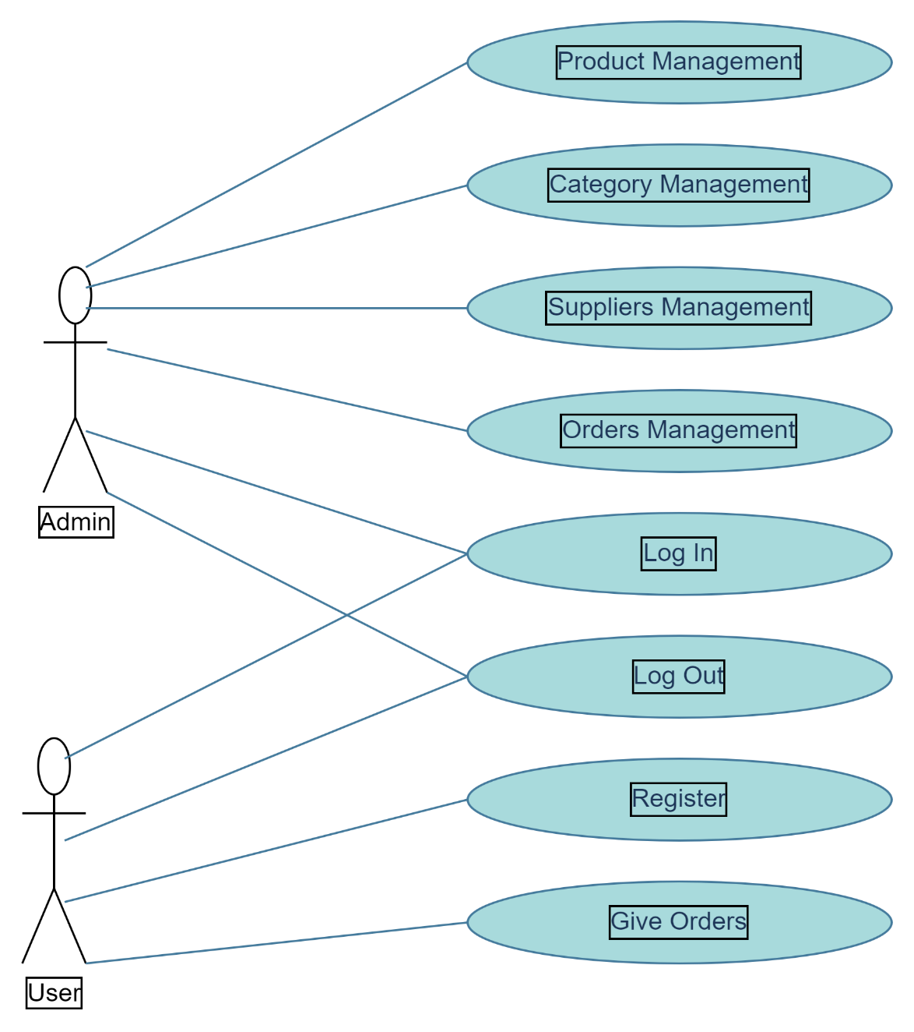

## **8-) SEQUENCE DIAGRAMS**

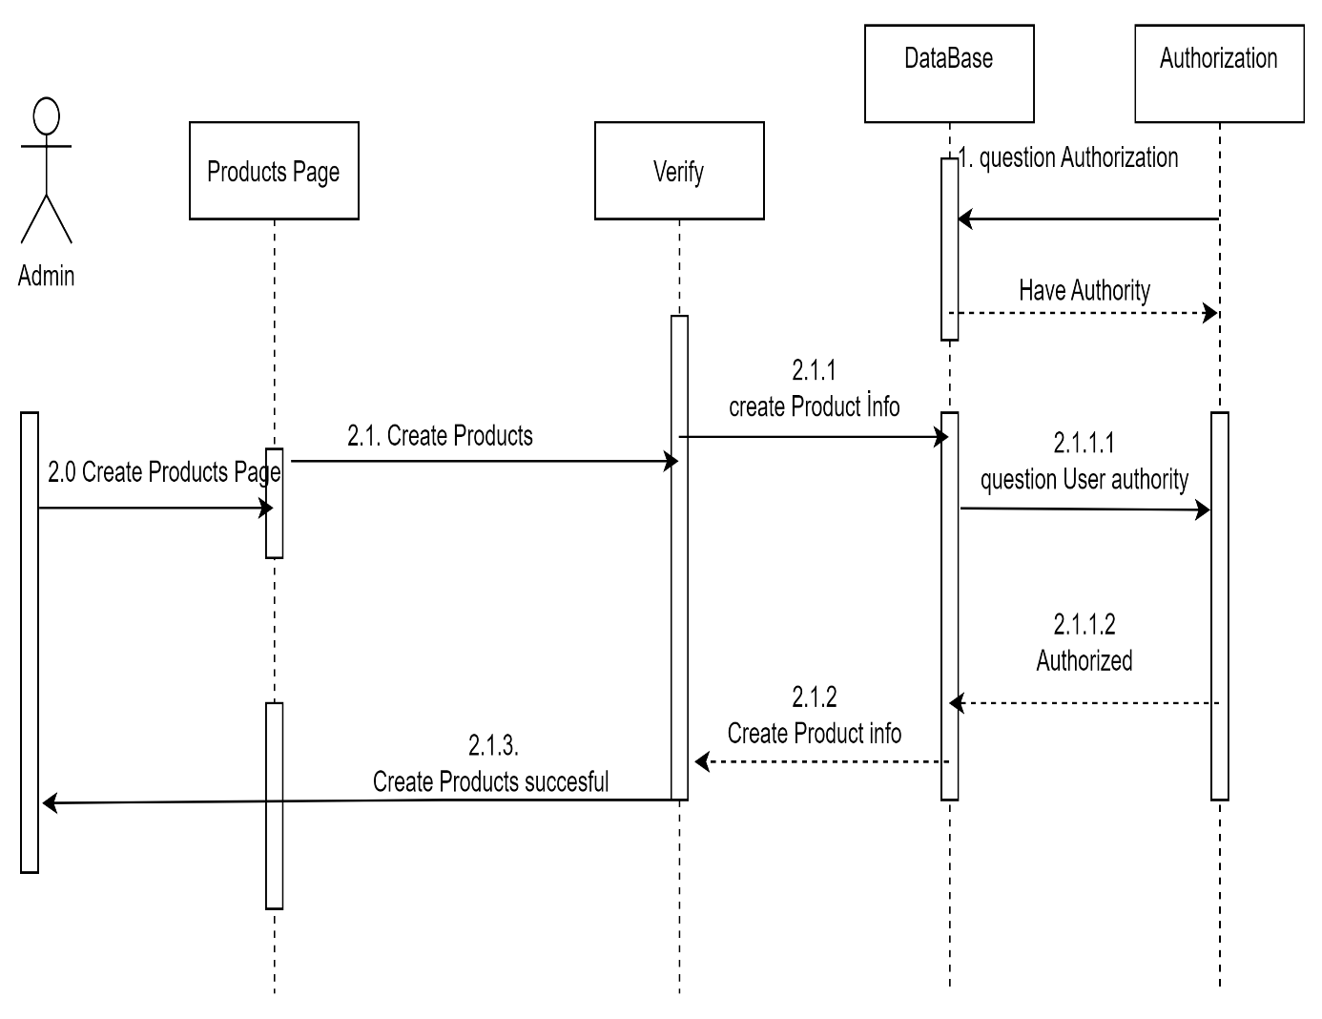

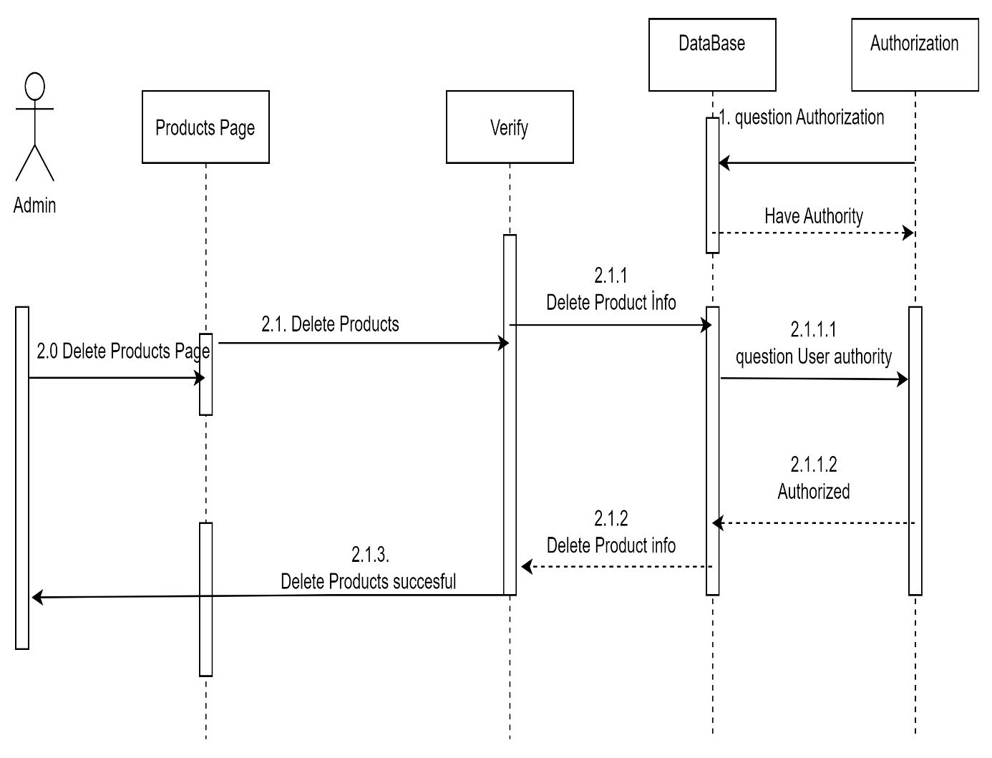

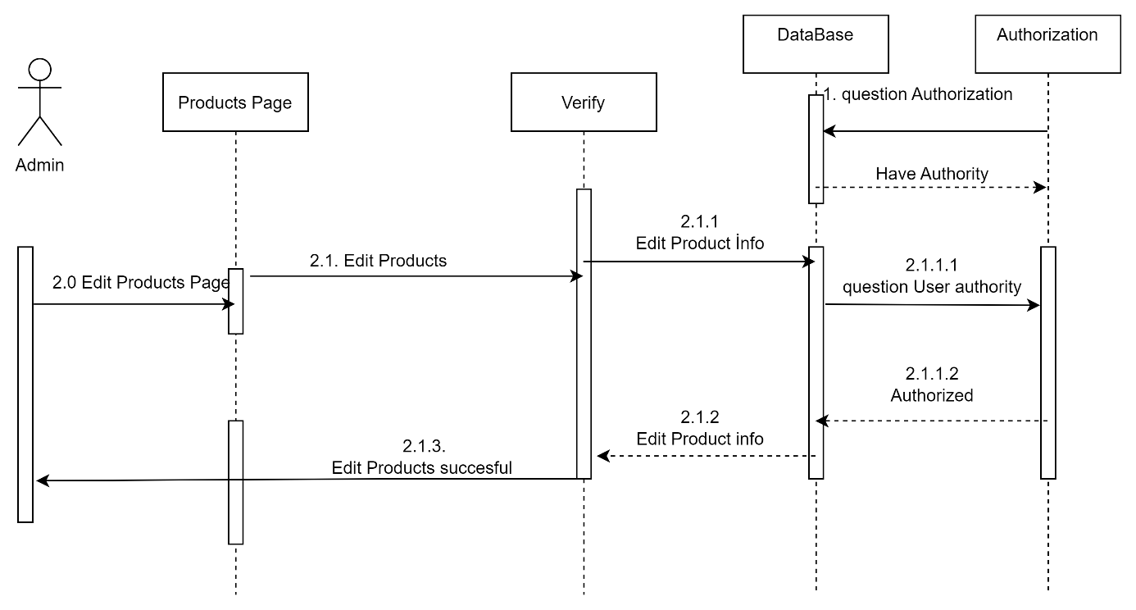

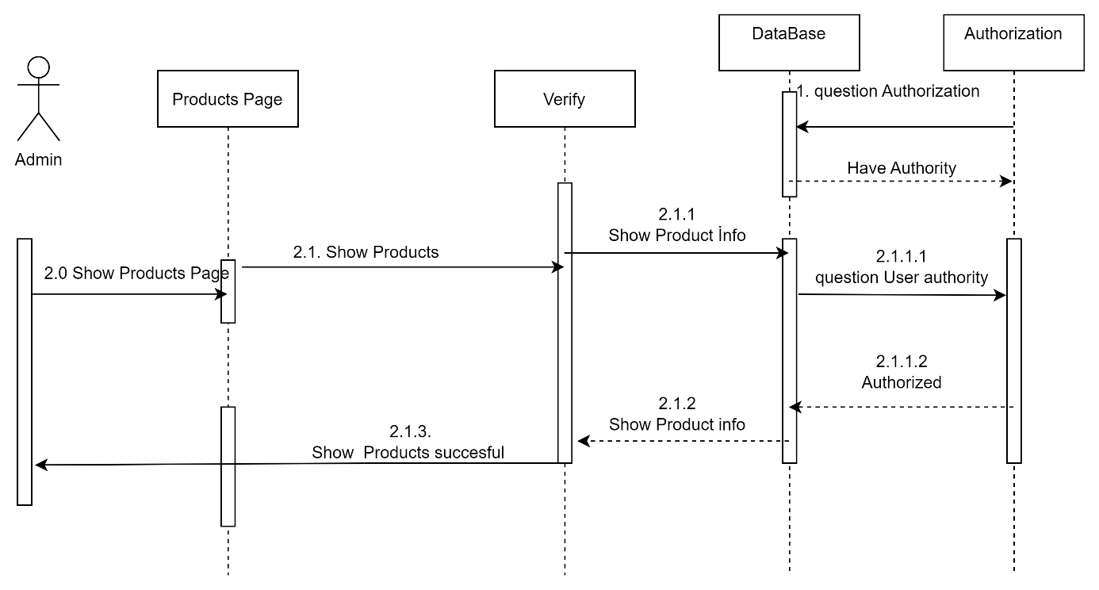

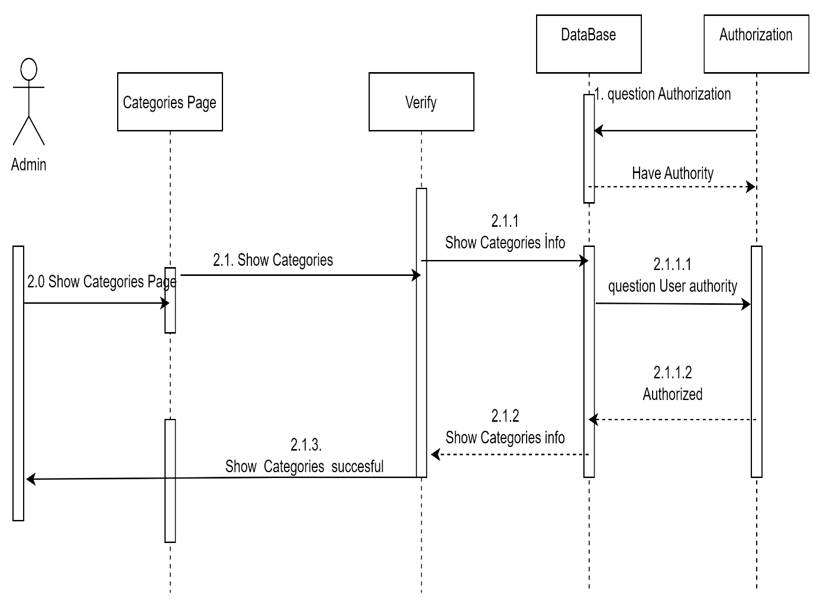

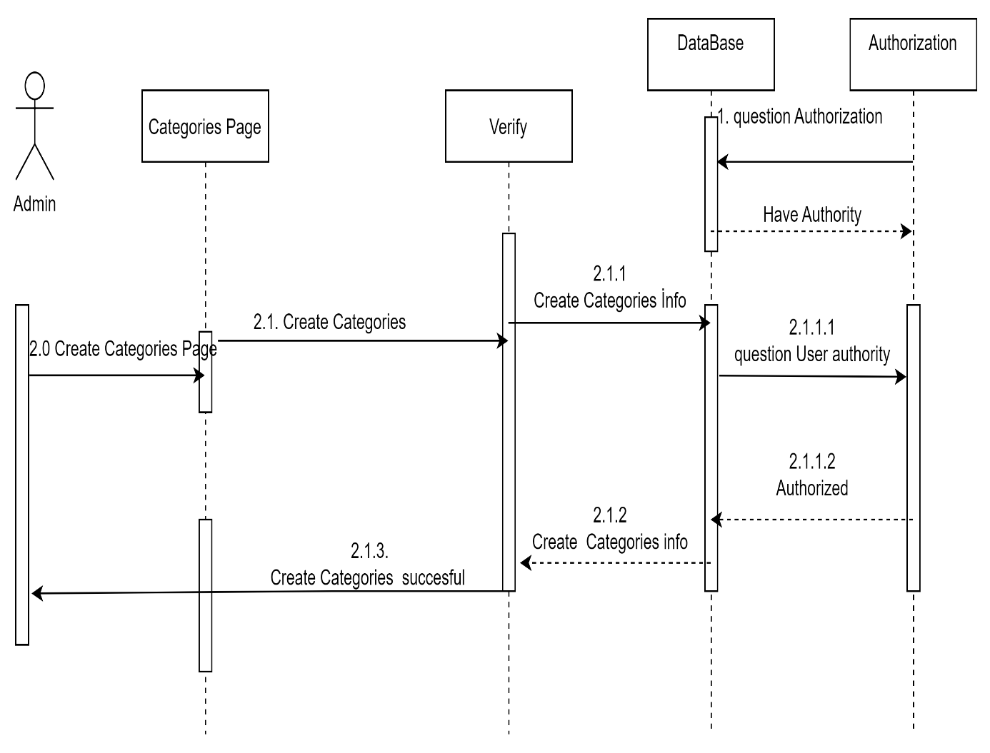

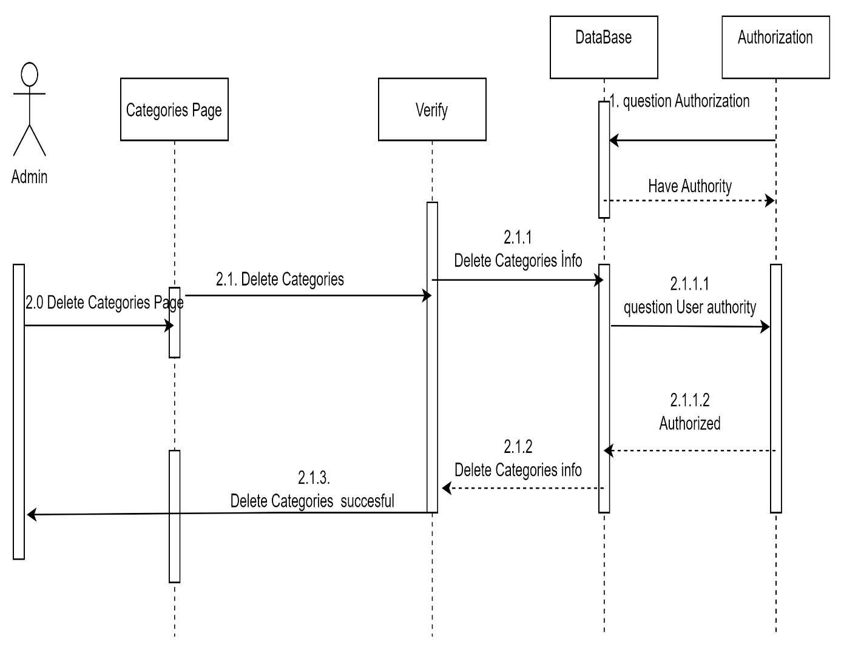

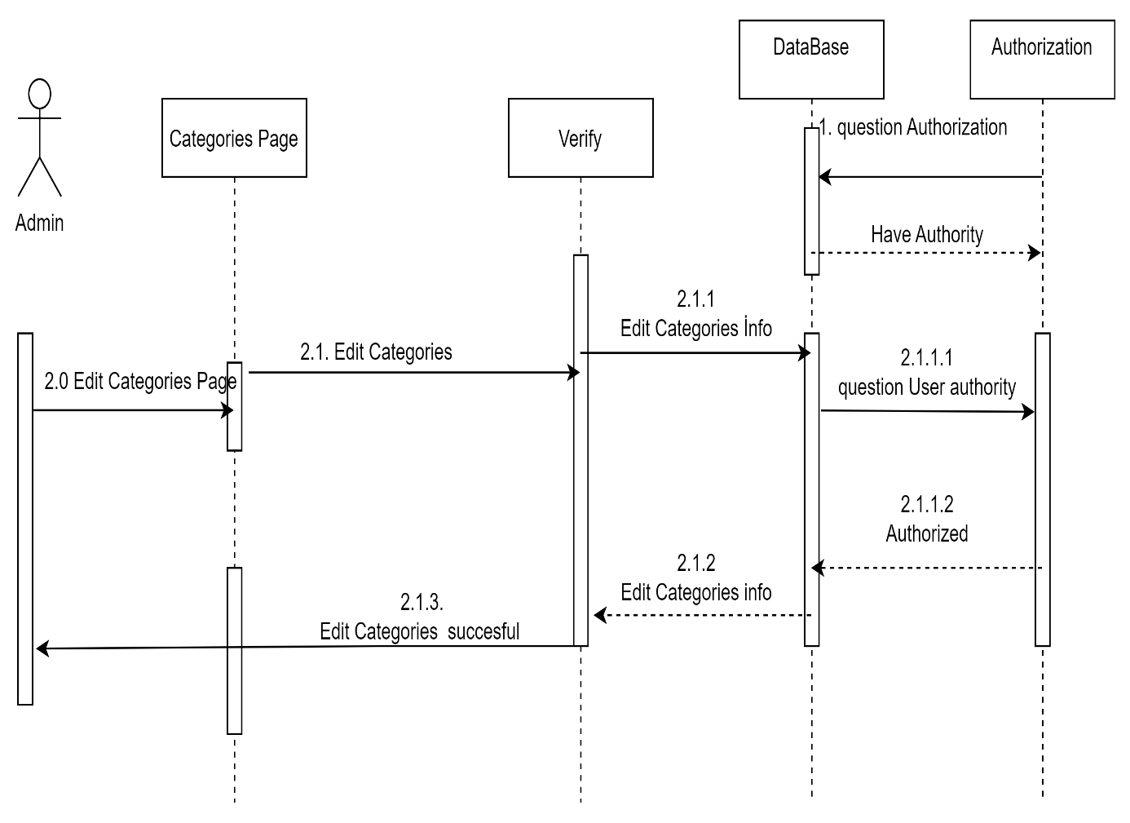

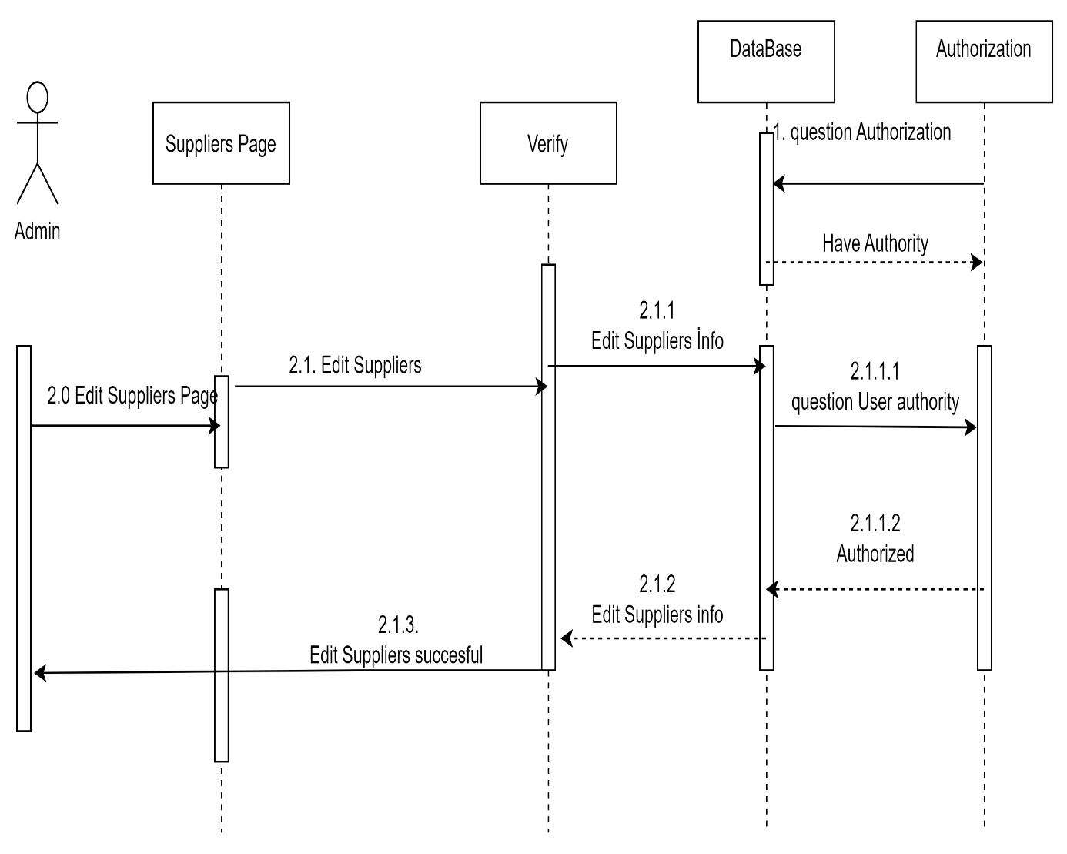

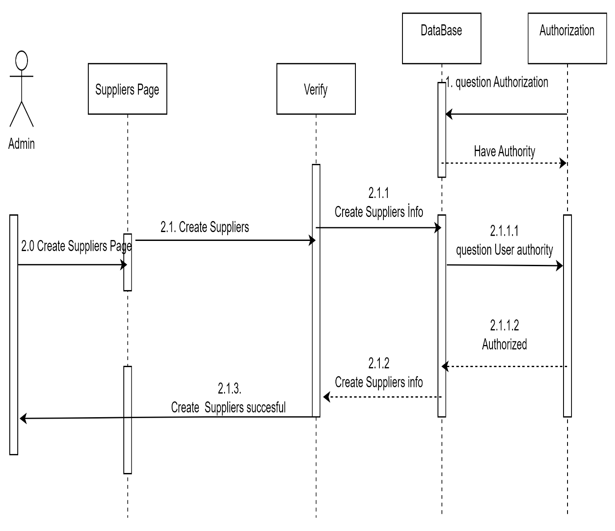

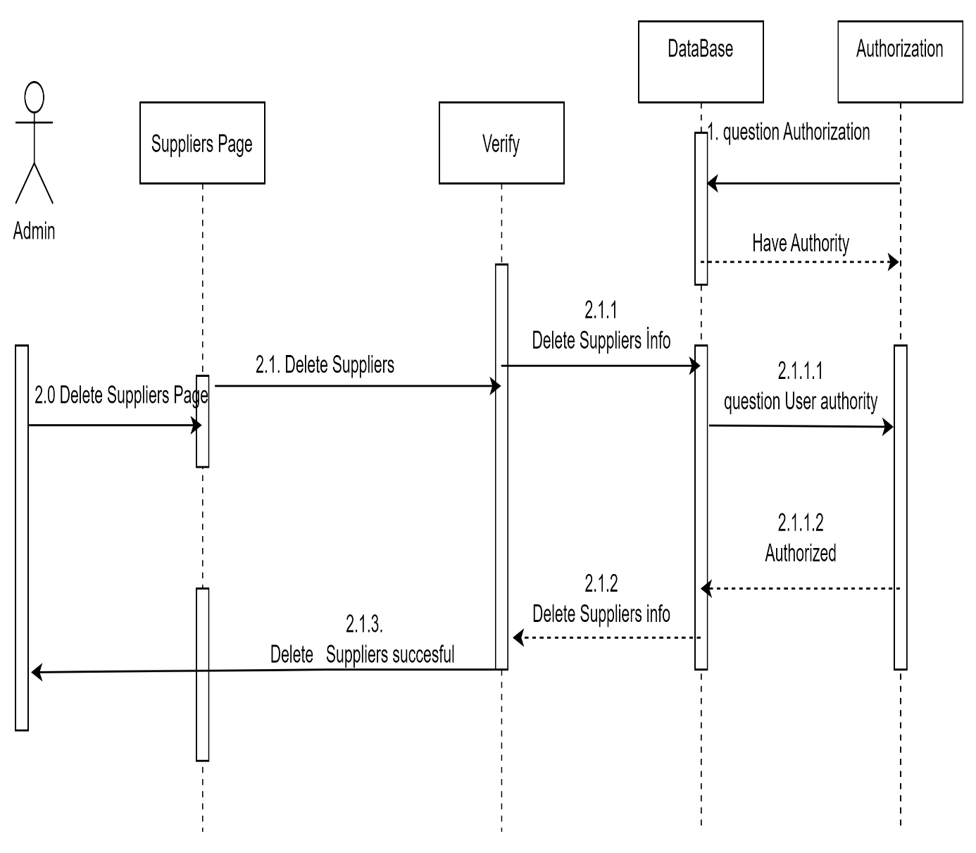

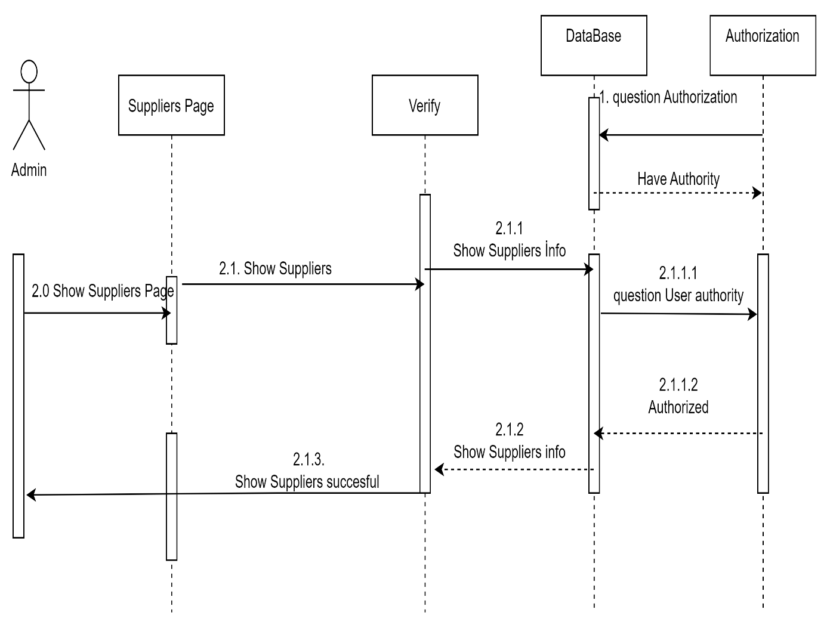

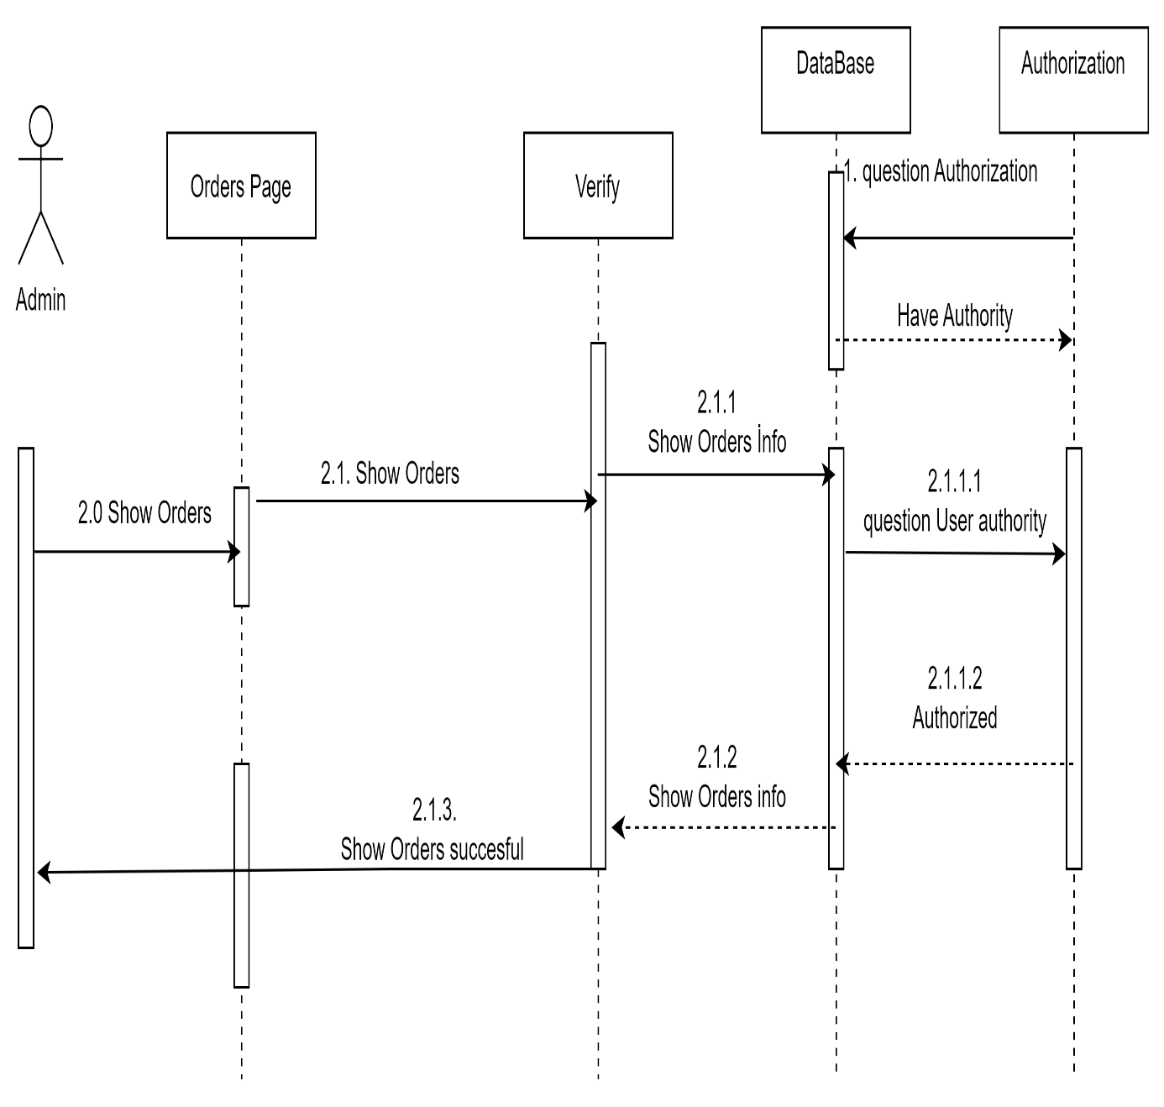

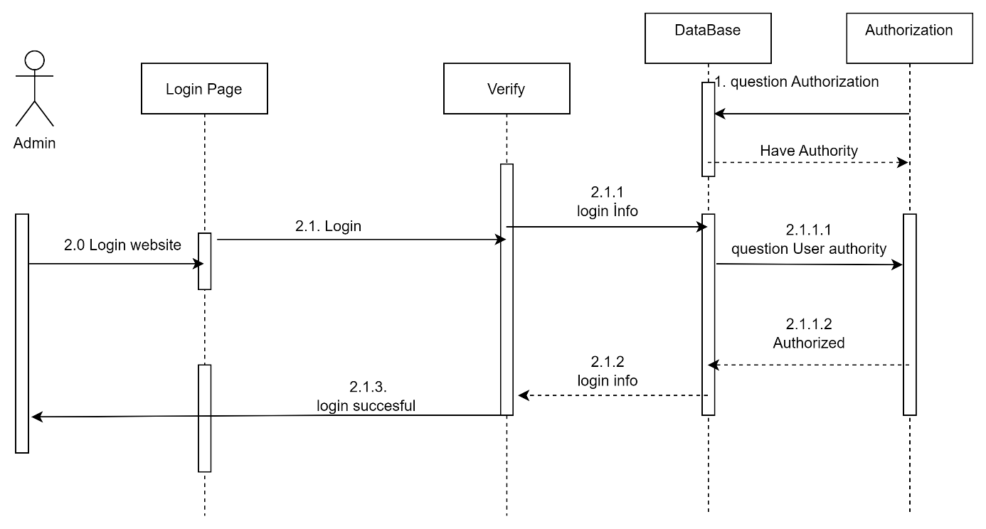

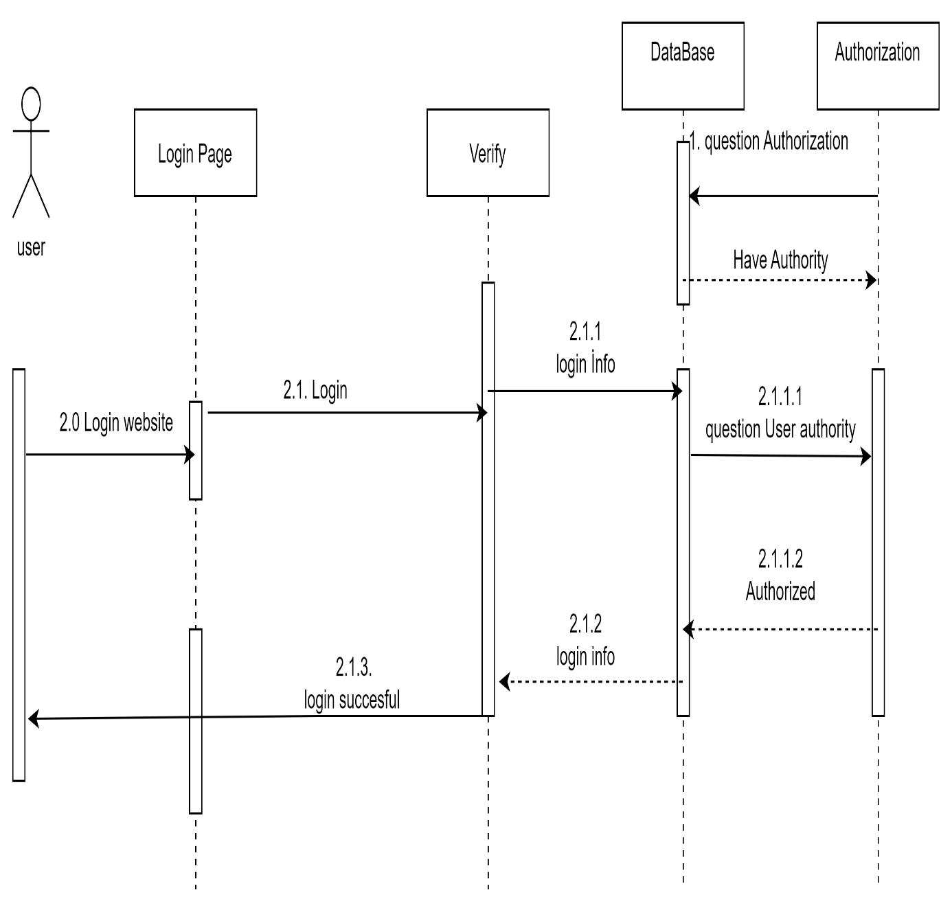

## **9-) TECHNOLOGIES USED AND THEIR DEFINITIONS**

1. **C#:**
   1. C# is the next generation programming language developed by Microsoft. It is one of the languages developed for .NET Technology, also developed by Microsoft.
2. **.net Framework:**
   1. .NET is a framework created by Microsoft that allows developers to build a wide range of applications, including desktop, web, and mobile applications, using languages such as C# and Visual Basic. It provides a large library of pre-built code and tools for common tasks, making it easier for developers to create high-quality, reliable applications. Additionally, .NET also includes an execution environment called the Common Language Runtime (CLR), which provides services such as memory management, type safety, and security.
3. **ORM:**
   1. . Object-Relational Mapping (ORM) is a technique for converting data between a relational database and an object-oriented programming language. he main idea behind ORM is to create a mapping between the database schema (tables, columns, etc.) and the classes and objects in the application. This allows developers to work with databases using a more familiar object-oriented paradigm, rather than writing low-level SQL statements.
4. **Entity Framework:**
   1. Entity Framework is an ORM and ORMs are intended to increase developer productivity by reducing the unnecessary tasks of persisting data used in applications.

## **10-) DESIGN PATTERNS TO BE USED IN THE PROJECT**

1. **Repository design pattern**
   1. It is a design pattern that enables data access and management to be reduced to a single point in data-centric applications
2. \***Builder design pattern**:
3. **Singleton design pattern**:
   1. A pattern that prevents the re-establishment of a class instance written in object-oriented programming and the creation of a different class instance each time is called
4. **Layered architecture** 
   1. layered architecture is a design pattern that helps to separate the different concerns of an application and make it more maintainable, testable, and scalable.

